Lab 5 Reflection

Proof

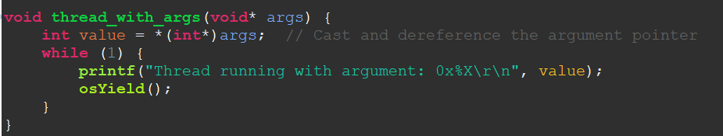
Thread with args function implementation
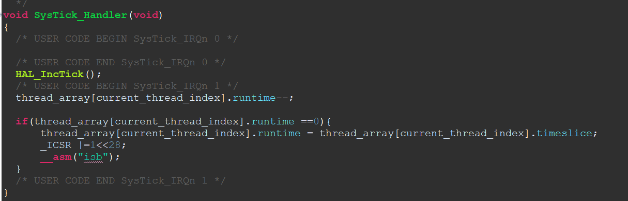
Systick handler function implementation
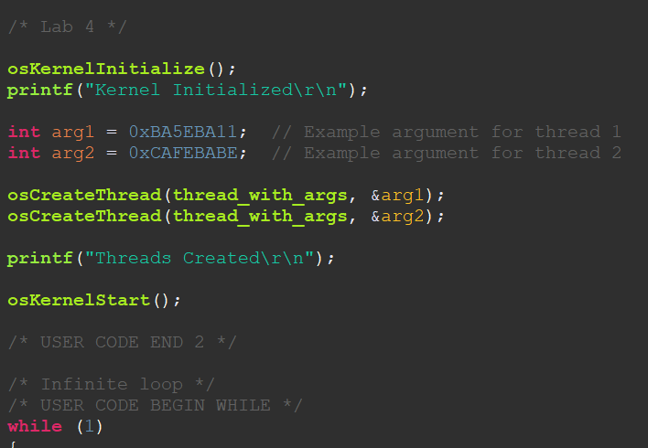
Kernel init with function calls
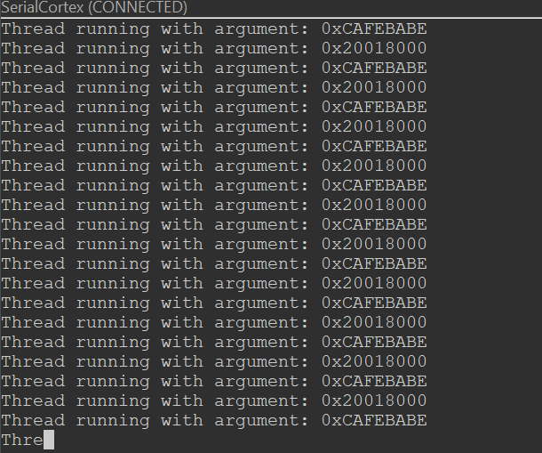
Functions calling back and forth
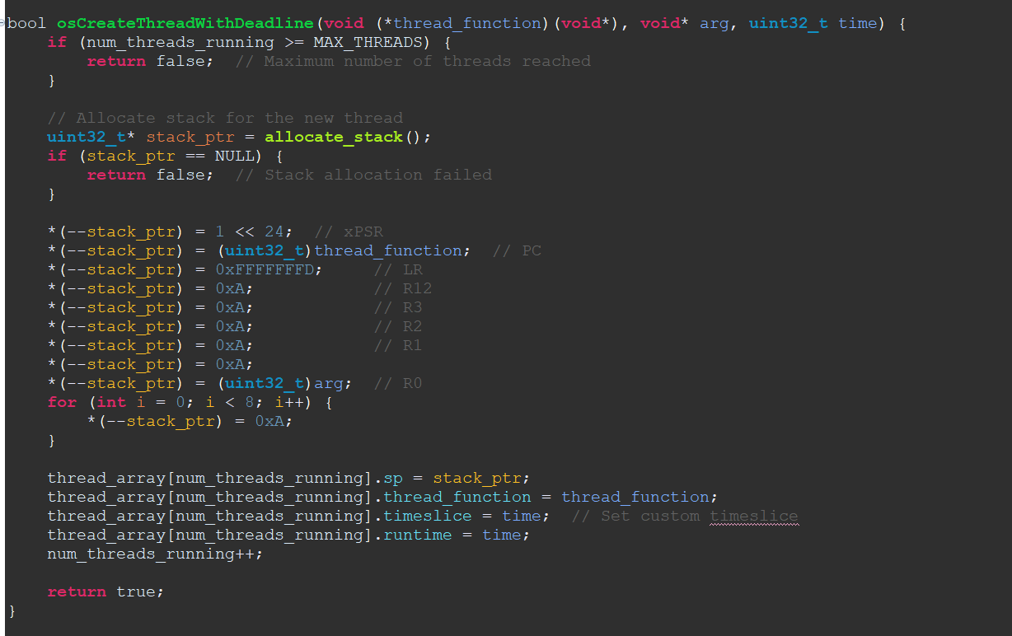
Thread with deadline function
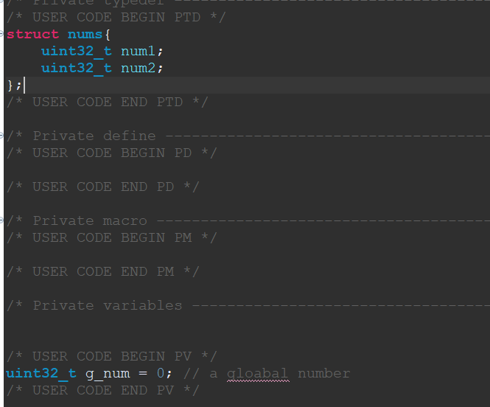
Custom struct declaration that will be passed as an arg later and global number to be iterated

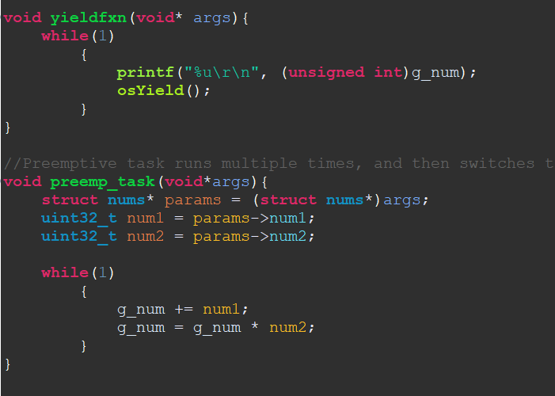
Yield function that is used in the
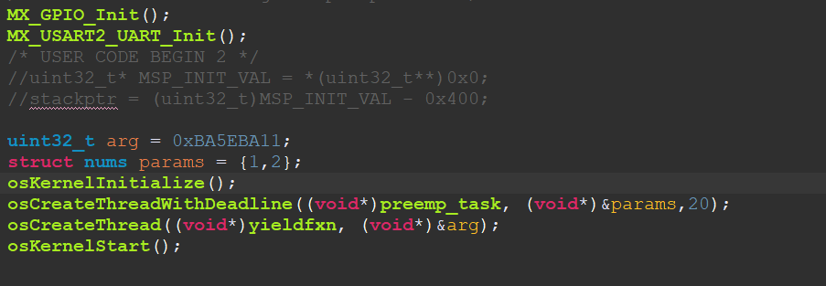
Thread with deadline and thread that calls yield thread initialization
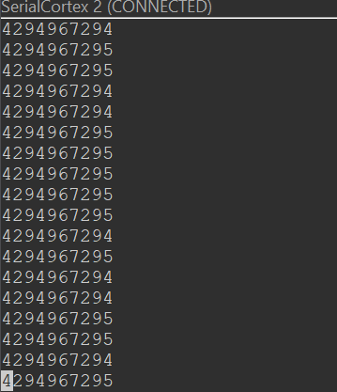
Output of serial console for task with deadline call

Question 1
Explain the process by which an argument gets passed into a thread. Begin with what the user has to do, then talk about what the OS has to do, and finally explain why it works.

Answer:
When passing an argument to a thread in an ARM Cortex-M system, the process involves several steps:
- User Action: The user defines the thread function with the desired parameters. According to the ARM Procedure Call Standard (AAPCS), the first four arguments are passed in registers R0 to R3. If there are more than four arguments, the additional ones are passed on the stack.
- Operating System (OS) Handling: The OS is responsible for setting up the thread's stack and initializing its context. This includes placing the function's arguments in the appropriate registers (R0 to R3) or on the stack, as specified by the calling convention. The OS also sets the program counter (PC) to point to the thread function's entry point and configures the stack pointer (SP) accordingly.
- Execution: When the thread is scheduled to run, the processor uses the values in R0 to R3 and the stack to access the function's arguments. This mechanism ensures that the function receives the correct parameters, allowing it to execute as intended.
This process works because both the compiler and the OS adhere to the AAPCS, ensuring a consistent method for passing arguments and managing function calls.

Question 2
Why can’t you call osYield in any of our context-switching functions (PendSV_Handler, SVC_Handler and its associated SVC_Handler_Main, and SysTick_Handler)? What happens if you do, and why is it bad?

Answer:
Calling osYield within context-switching functions like PendSV_Handler, SVC_Handler, and SysTick_Handler is problematic because these handlers are already executing at an elevated interrupt priority. Invoking osYield in this context can lead to unintended behavior, such as nested context switches or corruption of the stack, which can destabilize the system. It's essential to manage context switches carefully to maintain system stability.

Question 3
In this lab we set up the fundamental OS clock to be 1ms. Say we wanted it to be 0.1ms instead. Discuss the benefits and downsides of doing this.

Answer:
Configuring the OS clock to a 0.1ms (100 microseconds) tick rate has both advantages and disadvantages:
- Benefits:
  - Finer granularity in task scheduling, allowing the system to respond more quickly to time-sensitive events.
  - Improved precision in timeouts and delays, which is beneficial for applications requiring high-resolution timing.
- Downsides:
  - Increased CPU overhead due to more frequent timer interrupts, which can reduce the time available for executing actual tasks.
  - Higher power consumption, as the processor wakes up more often to handle the increased number of interrupts.
  - Potential for increased context switch overhead, which can affect real-time performance if not managed properly.
Therefore, while a higher tick rate can enhance responsiveness, it requires careful consideration of the system's performance and power constraints.

Question 4
Explain the difference between co-operative and pre-emptive multitasking from the user perspective and in terms of what the OS has to do for each one.

Answer:
In cooperative multitasking, tasks voluntarily yield control to the OS, typically by calling a yield function. The OS relies on tasks to provide opportunities for context switching, which simplifies the OS design but can lead to issues if a task fails to yield, potentially causing system unresponsiveness.
In preemptive multitasking, the OS forcibly takes control from tasks, usually through hardware timers like SysTick. This approach allows the OS to ensure that high-priority tasks receive CPU time, leading to better responsiveness and system reliability. However, it requires the OS to handle context switching and interrupt management, adding complexity.
From the user's perspective, cooperative multitasking requires careful design to ensure tasks yield appropriately, while preemptive multitasking provides a more seamless experience but may introduce challenges related to concurrency and shared resource management.

Question 5
The final exercise of this lab had you mix together yielding and time-based pre-emptive context switching. How is it possible for these two mechanisms to work together?

Answer:
Combining yielding and time-based preemptive context switching is feasible because they operate through different mechanisms. Yielding involves a task voluntarily giving up control, allowing the OS to schedule another task. Time-based preemption uses hardware timers to interrupt tasks after a specified period, enabling the OS to enforce multitasking.
By integrating both methods, the system can achieve efficient multitasking: tasks can yield when appropriate, and the OS can preempt tasks to ensure timely execution of high-priority processes. This combination enhances flexibility and responsiveness in task scheduling.

Grading
Each question is evaluated based on the following scale.
Meets expectations: The answer is entirely correct. The answer is sufficiently detailed to include the major ideas necessary to prove that the student understands the concept. The answer is clear.
Approaching expectations: The answer contains no incorrect statements, but requires more detail or is too vague to convince the grader that the student understands the concept. The answer is clear.
Does not meet expectations: The answer either contains some incorrect statements or lacks detail to the degree that major portions of the question are left unanswered. The answer is not clear.
Not observed: the answer is largely incorrect or absent.
To get a grade for a question, you must obtain a rating of “meets expectations” on that question. You may resubmit as many times you like until you achieve that rating.

